I’d Like To Thank Everyone Who Made This Year’s Everyone Deserves An Easter 2024 A Huge Success.

This year, more than ever, we have had to work effortlessly to make sure that families across our community were able to come together and celebrate Easter. With the ongoing cost-of-living crisis, I am so grateful that we have been able to come together as a community and help those in need this Easter, not just in Swansea but in the surrounding local areas, too. This year, I am so proud to say that we delivered over 400 hampers to those across South West Wales, helping to tackle hunger and take pressure off food banks at such an important time to celebrate.

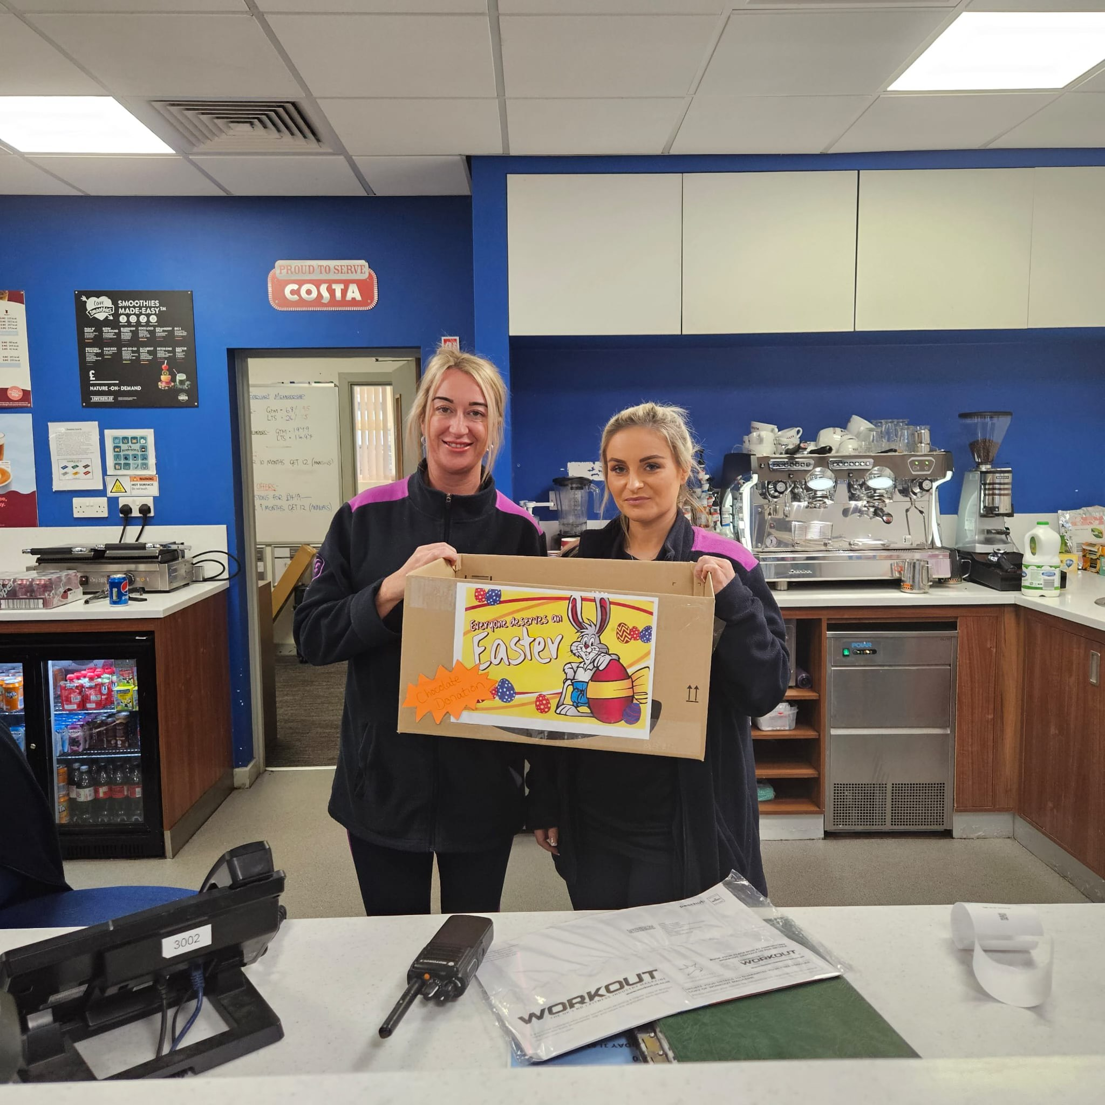
Preparing for Everyone Deserves an Easter 2024

During the run-up to Easter weekend, the team and I were busy collecting donations and dropping Easter eggs off at good causes. It warms my heart that local businesses were also collecting donations for us. A special thanks to Freedom Leisure Penlan, Morriston and Miss Jones Boutique, who supported our campaign by setting up collection points for donations.

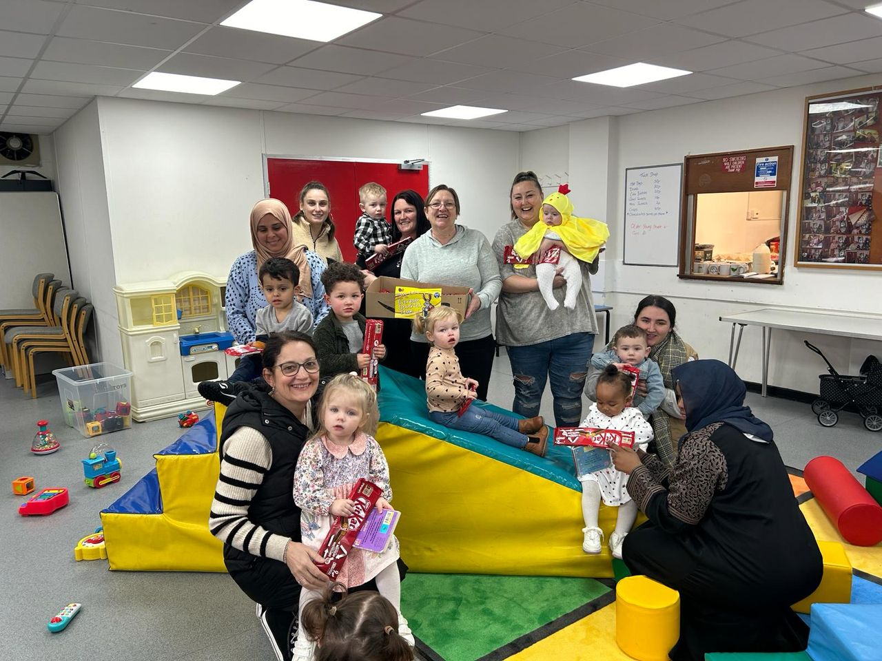
During the week before Easter weekend, we delivered hundreds of chocolate treats to the local community. We delivered to Penlan South community centre who organised an Easter breakfast for children, Manselton Youth Club, East Swansea Eagles Girls Rugby Club, Plasmarl Community Centre, Ospreys in the Community and WRU for their Fun, Fit and Fed camps, Cwmbwrla Brownies, Mother and Toddler group in Port Tennant community centre and to the Bonymaen play initiative who had Easter activities that week. It was certainly a busy week for the team!

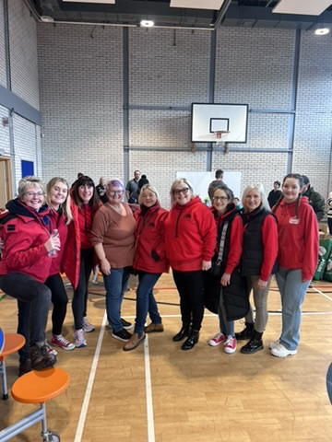
This Easter, we received donations from lots of local businesses in the community. I’d like to thank Mecca in the community, Bronwen from the University of Wales Trinity Saint David for their Easter egg donations, Castle Bingo Neath for Easter eggs and a monetary donation, Whitehead Building Services, Stacey Yuen Aveda, Sally from the Development Bank of Wales for their Easter egg donations and Dr Organic for their kind donations to go in the Easter hampers.

Finally, I would like to give a very special thank you to Valley Rock Voices, which not only donated 250 Easter eggs but also came to help us with the packing for the hampers. You guys are amazing!

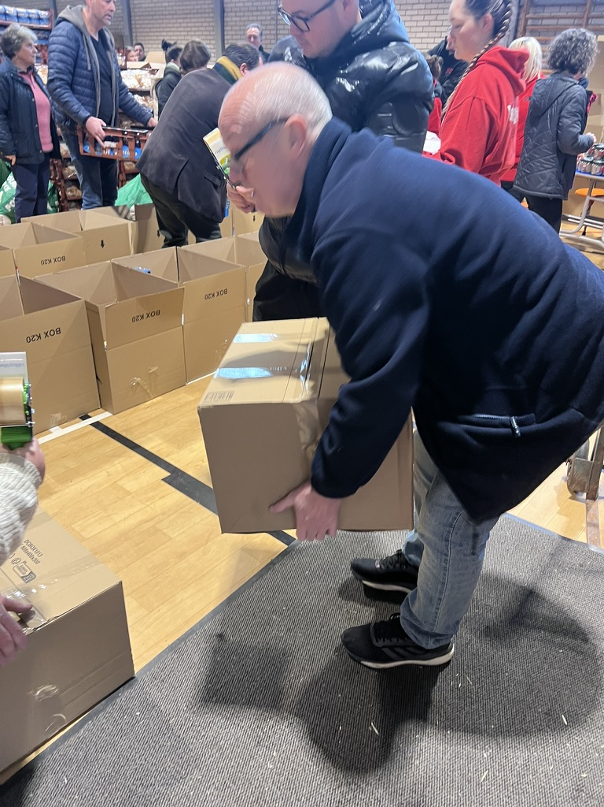
Hamper Packing and Delivery Day

The day before hamper packing day, the weather decided to give us every season in one day, including snow! That didn’t stop us, however, from waking up bright and early to head down to Pentrehafod School to get ready for the busy day ahead.

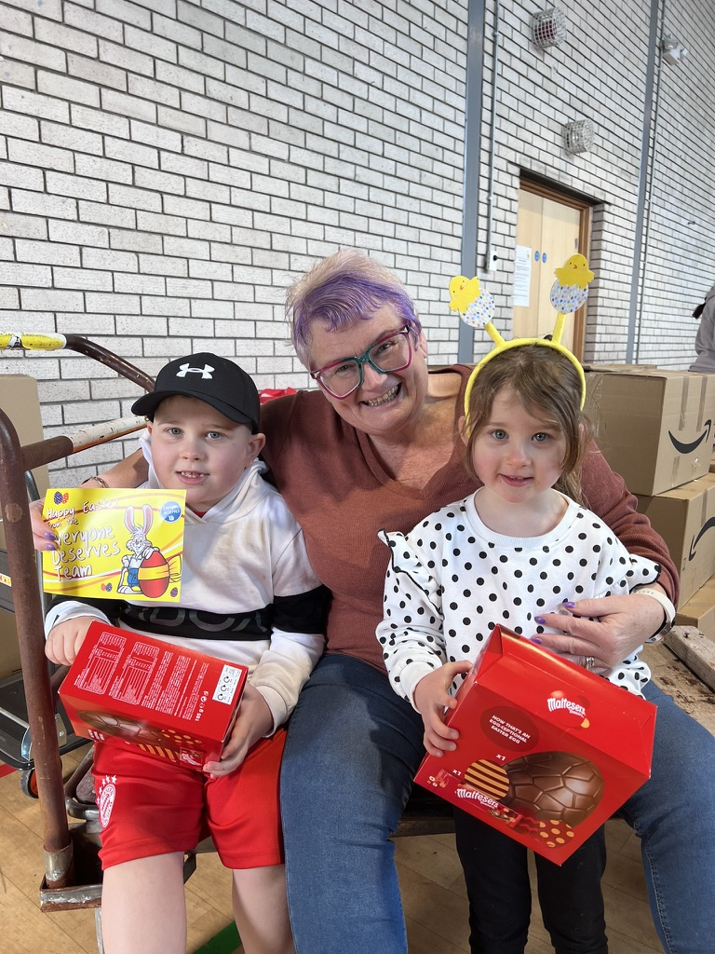
Unfortunately, the weather wasn’t on our side, but the community still showed up to help pack and deliver the hampers. A special thanks to the incredible Vally Rock Voices, NAS Swansea, Coastal Housing Group, Swansea Council, The LCV Group, WRU, Greenspace SOS, Swansea Council, ADS, Peter Lynn and Partners, Ebbw Vale Institute, Ospreys In the Community, Swansea City AFC Foundation and the staff at Pentrehafod School. Thank you to each and every one of you! Without you all, we would not be able to do what we do.

All of these organisations are certainly the backbone of our community. I am so grateful for their support and the support of my political neighbours Julie James MS, Stephen Kinnock MP, Jeremy Miles MS, Nick Smith MP and Gerald Jones MP. These guys are a vital part of making sure that the hampers and eggs are reaching those who need them the most and do a lot of the heavy lifting when it comes to receiving donations.

With all of the help we received from the community, by midday, we were able to pack and start delivering all the hampers. I’d like to give a special thanks to Castell Howell, who make sure every year that we have everything needed to provide a delicious Easter dinner in our hampers. Everyone Deserves would certainly not be possible without you!

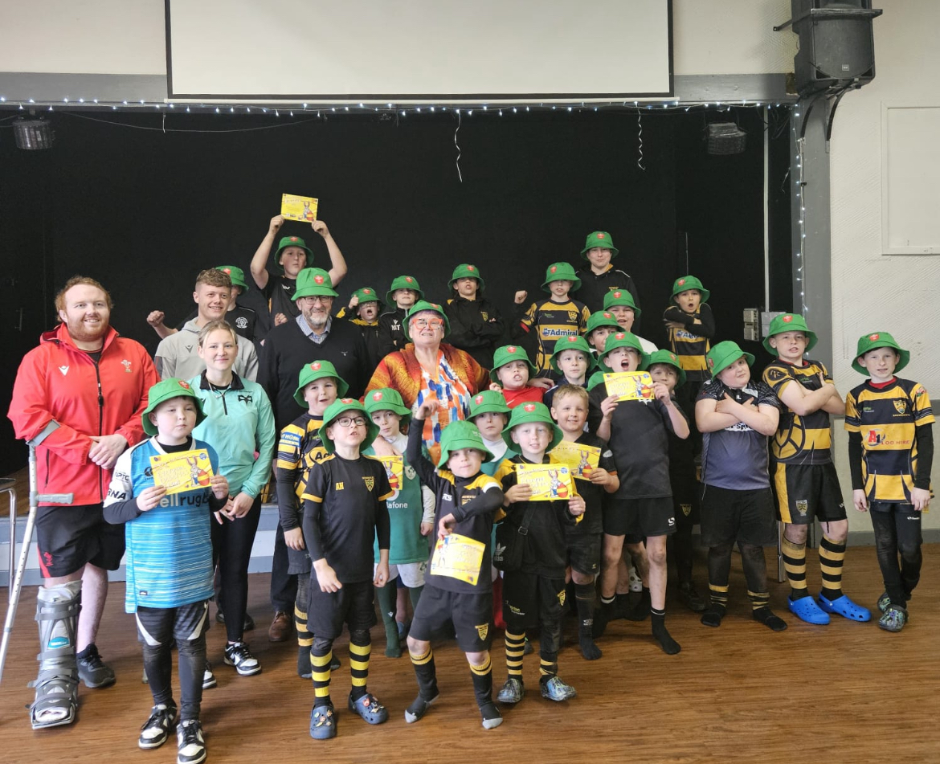

To wrap up, Everyone Deserves an Easter; I got involved in a number of amazing events put on across our community through the Easter weekend.

I was very excited to provide Ospreys in the Community and the WRU with breakfast and lunch as part of their Fun, Fit and Fed camps. I also popped down to Bonymaen RFC to deliver some crème eggs.

Once again, thanks to everyone who made this possible! Here’s to another successful Everyone Deserves an Easter.

Carolyn

