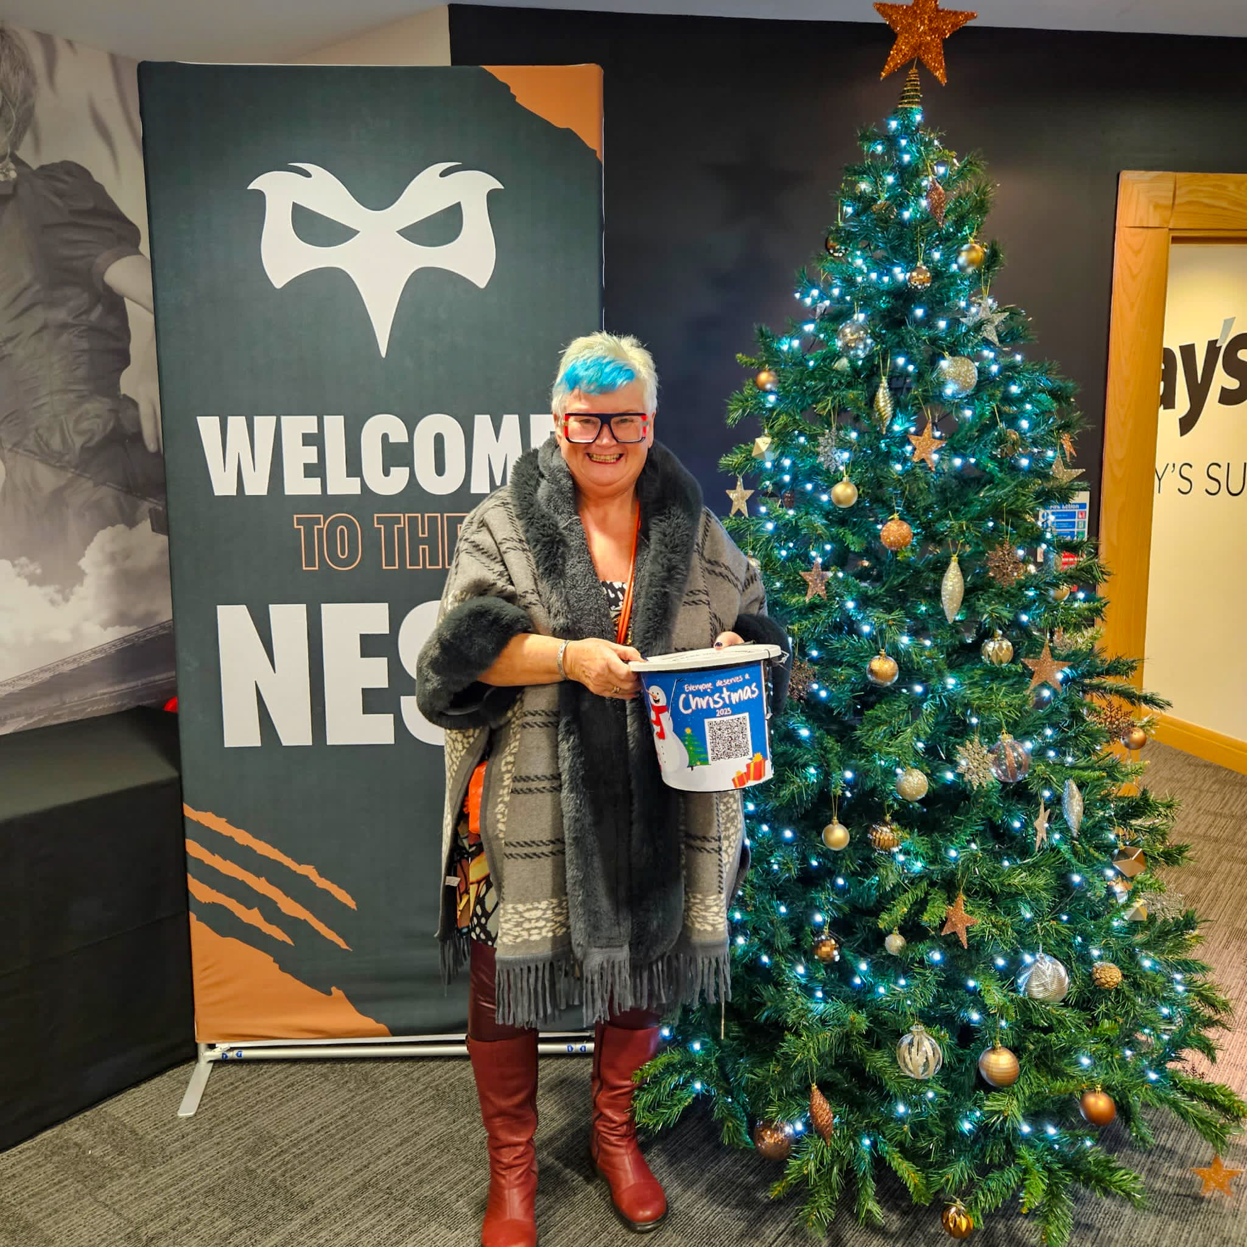
When this community comes together magical things happen, so, to the amazing people who supported Everyone Deserves A Christmas 2023, I want to give a special thank you…

In Swansea and the surrounding areas, Father Christmas and his elves weren’t the only ones who were making things happen this month. So, to the amazing people who supported Everyone Deserves a Christmas 2023, I want to say a heartfelt thank you.

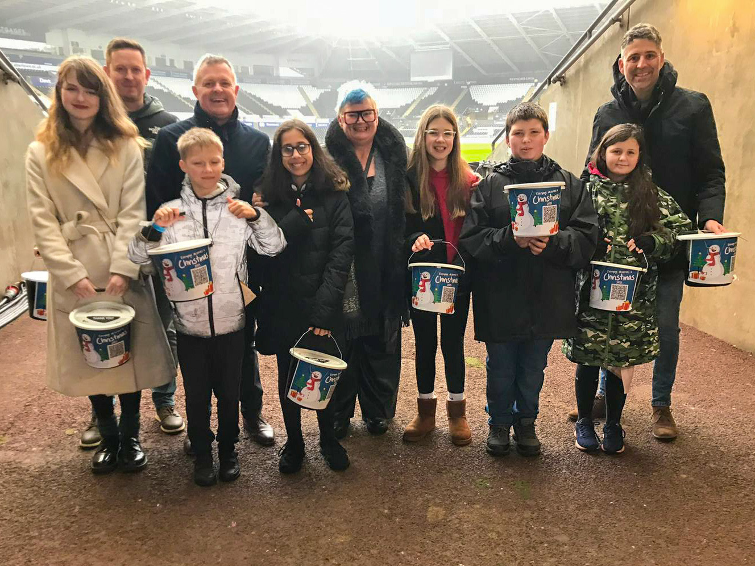
Every year our festive hampers make a significant difference to the lives of those who might otherwise go without, and this year we were able to reach more households – in more areas – than ever before. In total, 1200 hampers were delivered to families across six constituencies - Swansea East, Swansea West, Neath, Aberavon, Blaenau Gwent, and Merthyr Tydfil & Rhymney. Thanks to my colleagues in those areas for their help and their continued support – Julie James (Swansea West MS), Jeremy Miles (Neath MS), Stephen Kinnock (Aberavon MP), Nick Smith (Blaenau Gwent MP) and Gerald Jones (Merthyr Tydfil & Rhymney MP). Because of our amazing communities and the generous donations from local businesses we were able to make a positive impact and bring some seasonal joy to so many people this Christmas.

EDAC 2023 Launch, Dec 1st
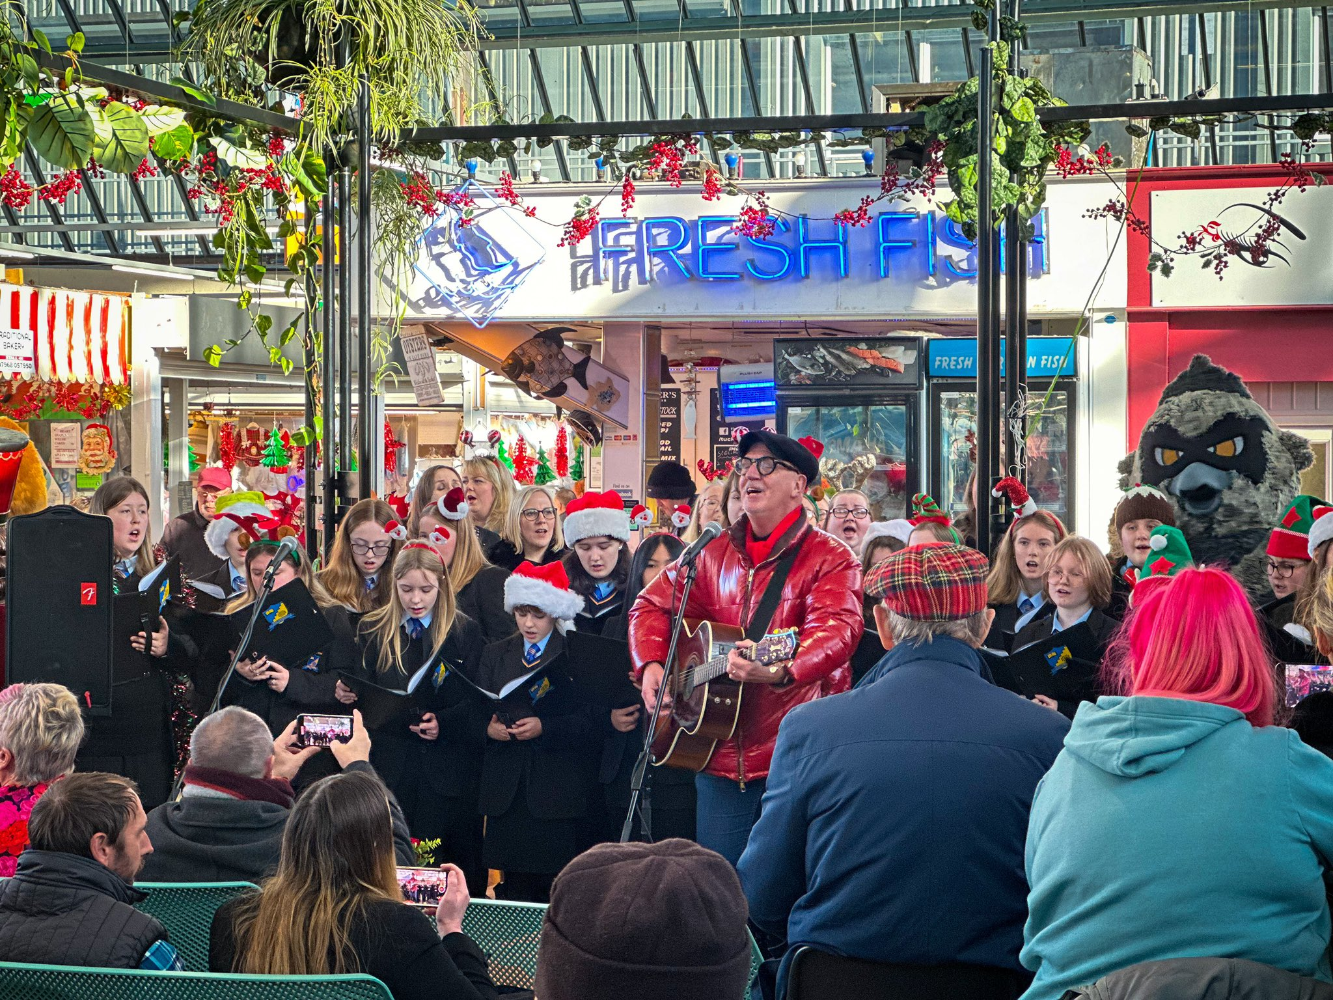
The magic of Christmas began in Swansea Market on the first of the month, when the community gathered together to enjoy the annual launch of our Everyone Deserves a Christmas campaign. We were treated to some beautiful singing from the infamous Mal Pope, alongside the amazing choirs from the DVLA and Pentrehafod School. Mal launched his festive song “Everyone Deserves a Christmas”, specially written to raise funds for the campaign, reminding the good people of the community what a difference their donations would make. A special thank you to everyone who donated to the bucket collection on the day, to those who came along and brought cheques and to Nationwide for match funding everything raised at the launch.

Bucket Collection

Once again, this year the support from the local community in raising funds for the campaign, was outstanding – and as always, the contributions made to our bucket collections, were the pinnacle of this. On the 9th December, the East Swansea Eagles girls rugby team, came out in force to help with the bucket collection at the Osprey’s game – it was smiles all round thanks to the winning result and the generous donations of those who had come to watch.
On the 9th December, the East Swansea Eagles girls rugby team, came out in force to help with the bucket collection at the Osprey’s game – it was smiles all round thanks to the winning result and the generous donations of those who had come to watch

And yet, More thanks

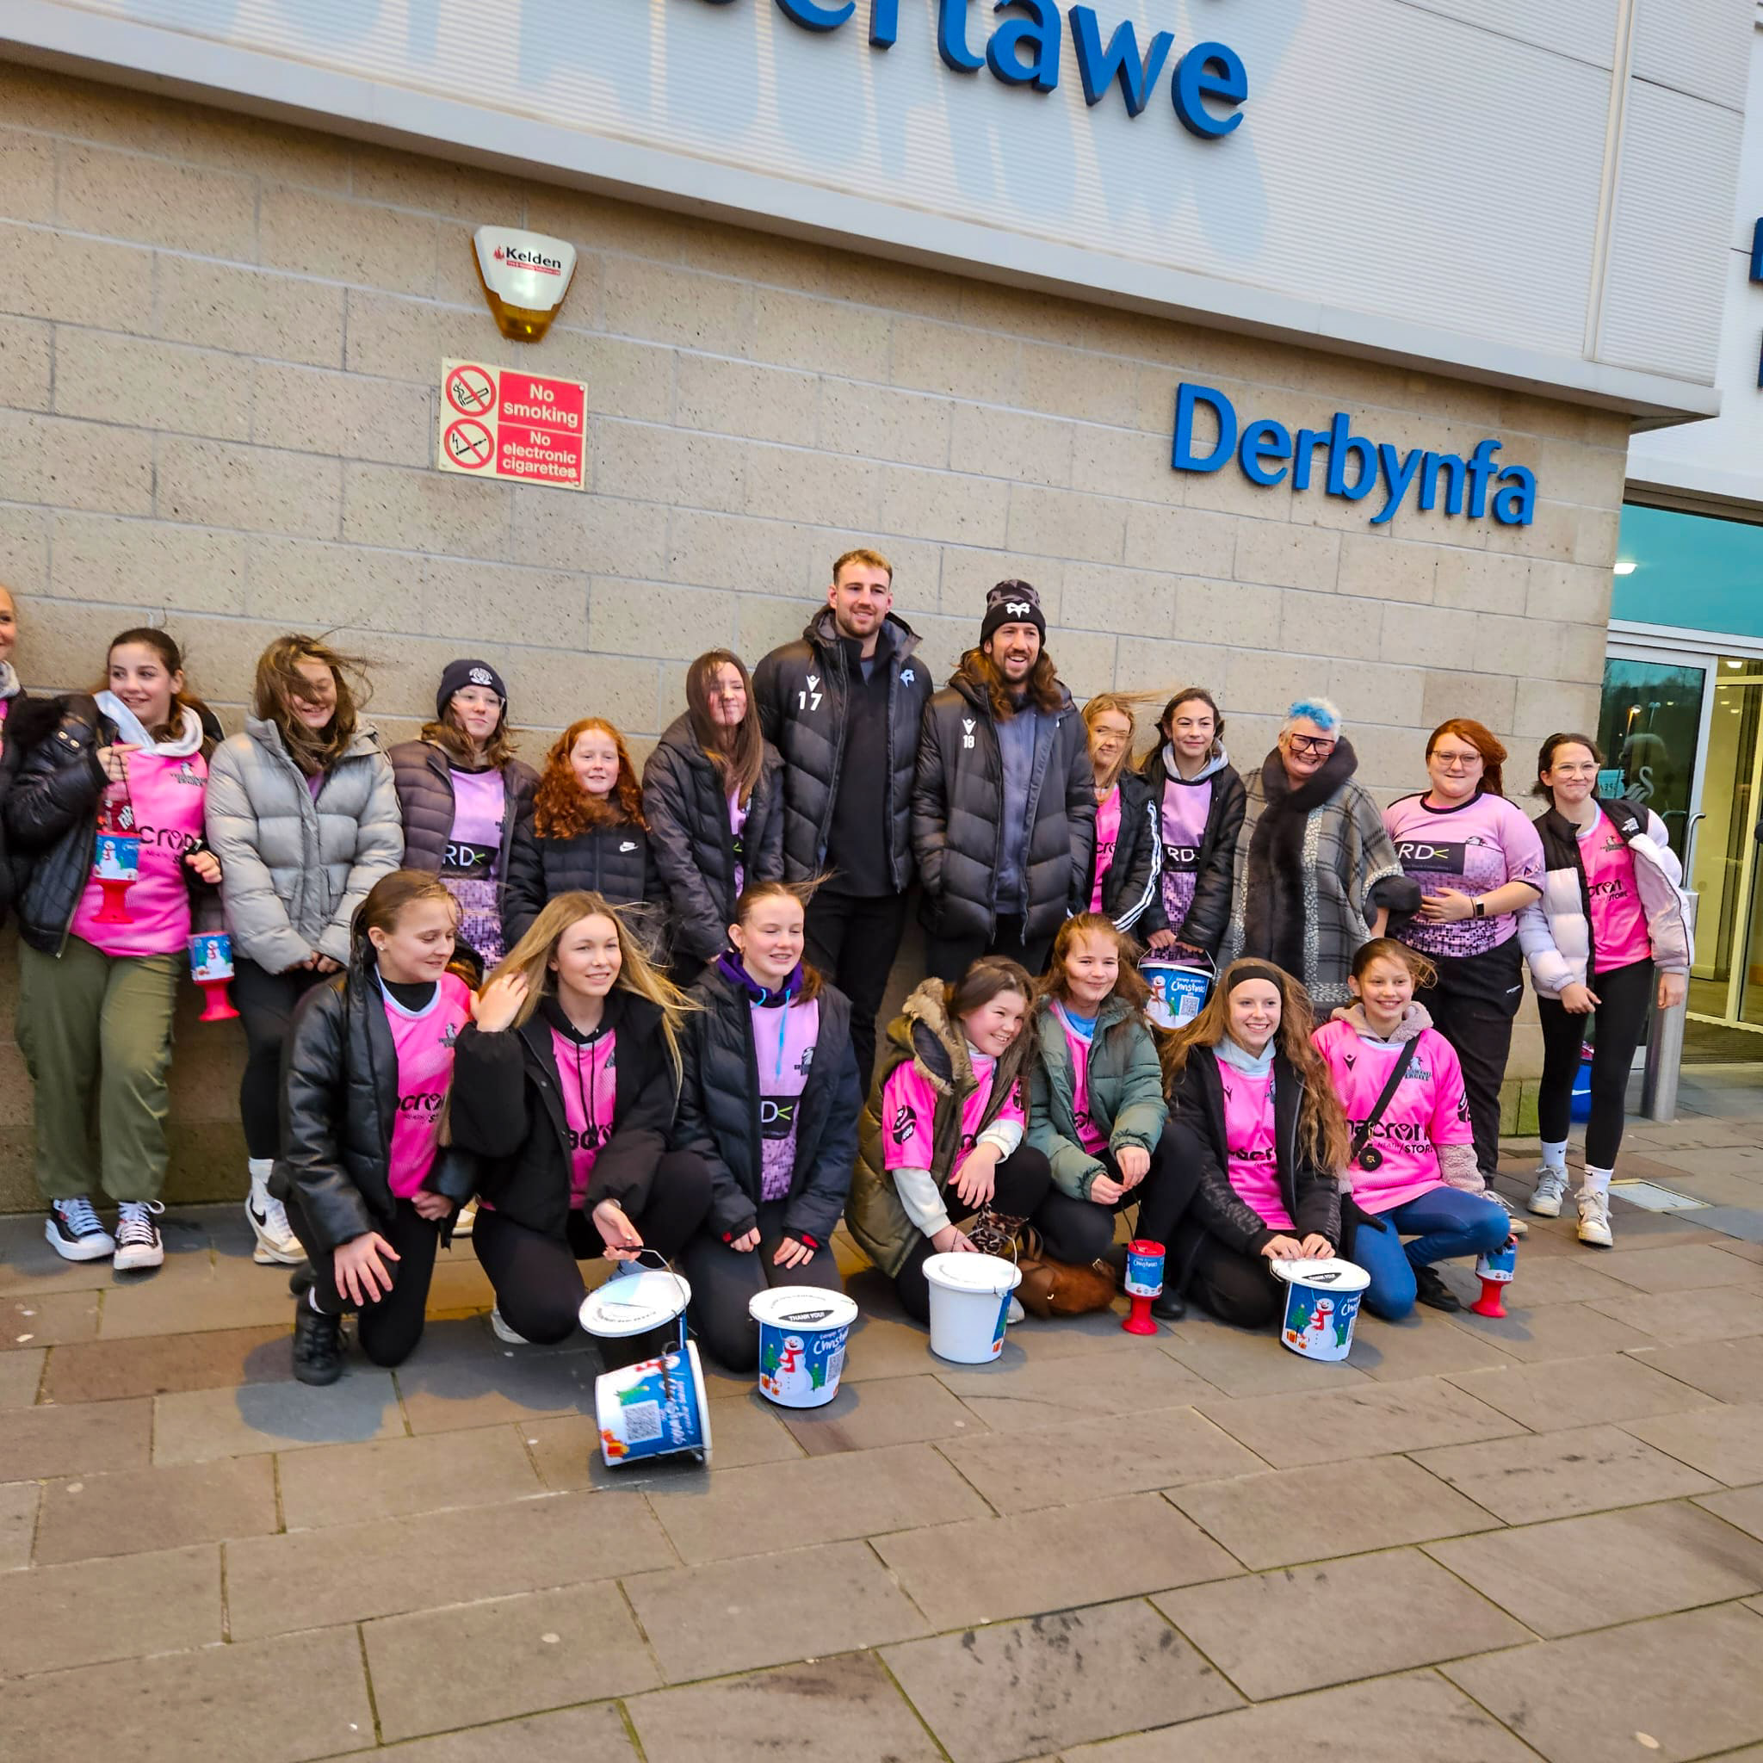
Whilst every donation, big or small, is gratefully received – there are some special people that need to be thanked this year for going above and beyond to help the campaign.

- The absolute legend that is Rod Stewart. When I asked his wife Penny if he could donate a little something for our charity auction, he sent us his own signed Celtic shirt, a signed album collection and a signed bottle of his own brand ‘Wolfie’ whisky. Those items alone raised over £3000 towards the cost of the hampers.
- Swansea Council who generously donated £10,000 to the campaign. With counsellors knowing first-hand, the difficulty that many in their communities are experiencing, it really is wonderful to be able to work with them to help to those who need it the most.
- And last but not certainly least, thank you to the Valley Rock Voices who took Everyone Deserves under their wing this year and continually raised money at concerts, events, and raffles totally £2500 – you guys are amazing, even providing some music entertainment whilst the hampers were being packed!

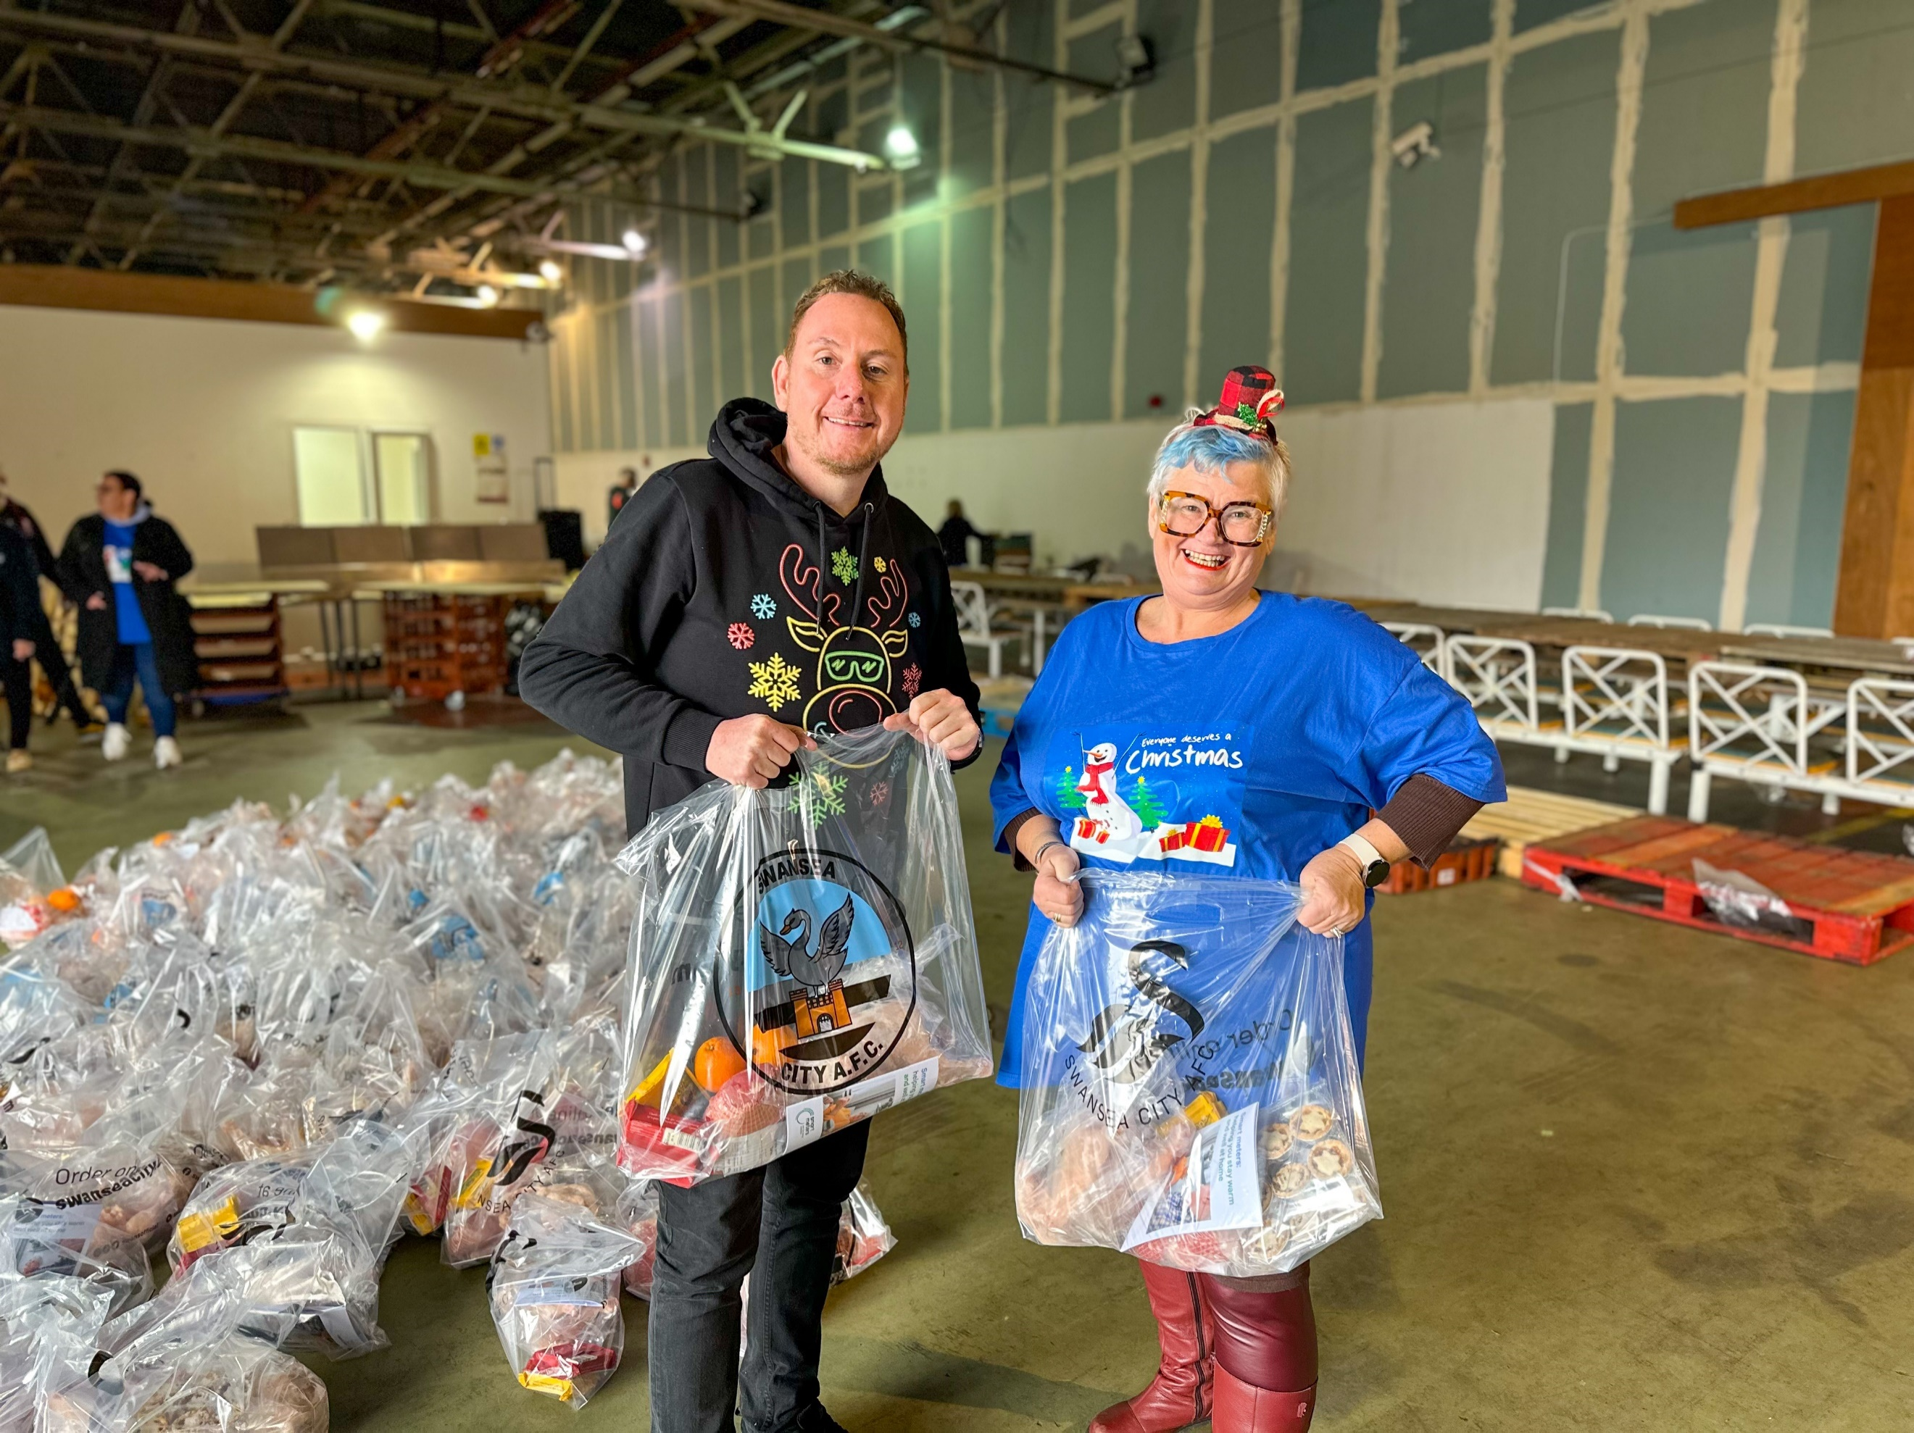
The finale! Packing and Delivering Hampers and Dinners

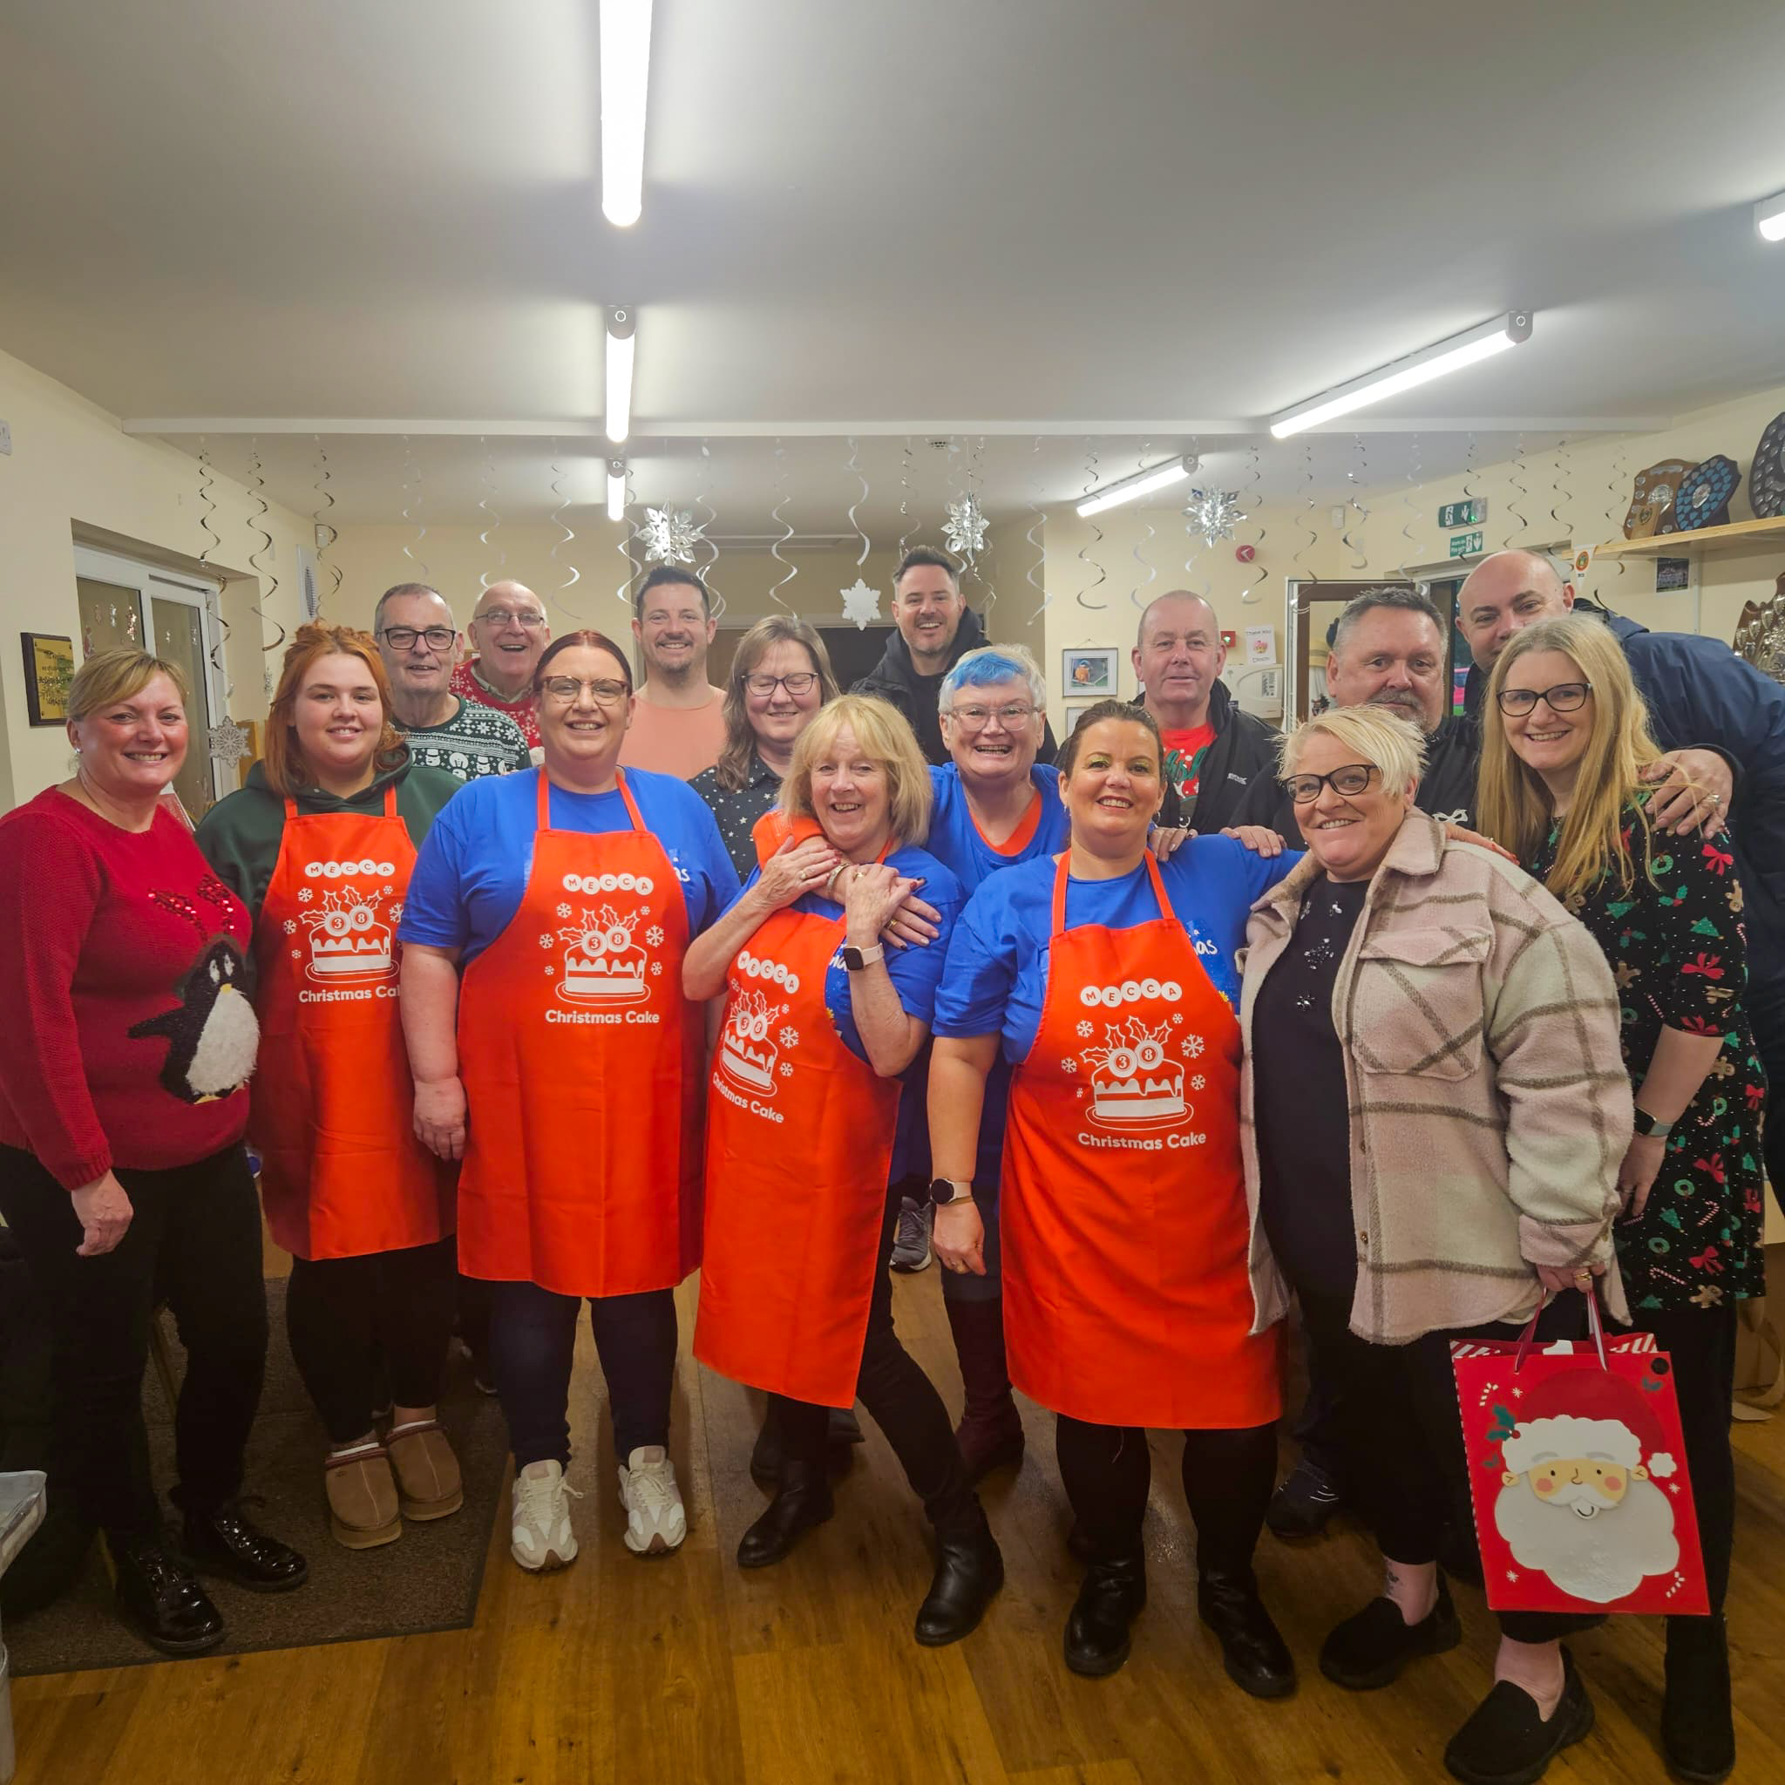
As has been the case the last few years, Bay Studios became home the week before Christmas, as we took delivery of the food, packed hampers and loaded them onto vans for delivery. There are way too many people to mention individually (and I don’t want to miss anyone) but thanks to the hundreds of volunteers who braved the rain and wind on Thursday 21st December to come and help pack hampers. Whether you were making boxes, filling boxes, making cups of tea for the troops, or were one of the unlucky ones who got stuck separating and backing 1200 frozen chickens – I cannot thank you enough. I will just name check Edward from Castell Howell – our wholesale food partner this year – who not only got up at the crack of dawn to deliver all the food, but stayed to help with the frozen chickens until the last one was bagged.

Thanks too to the army volunteers who spent Friday the 22nd December on the road delivering 1200 festive hampers to households across South Wales. Again, there are just too many to thank individually but there were some real lifesavers who came back time and again to collect more hampers and make sure that every one of them got delivered.

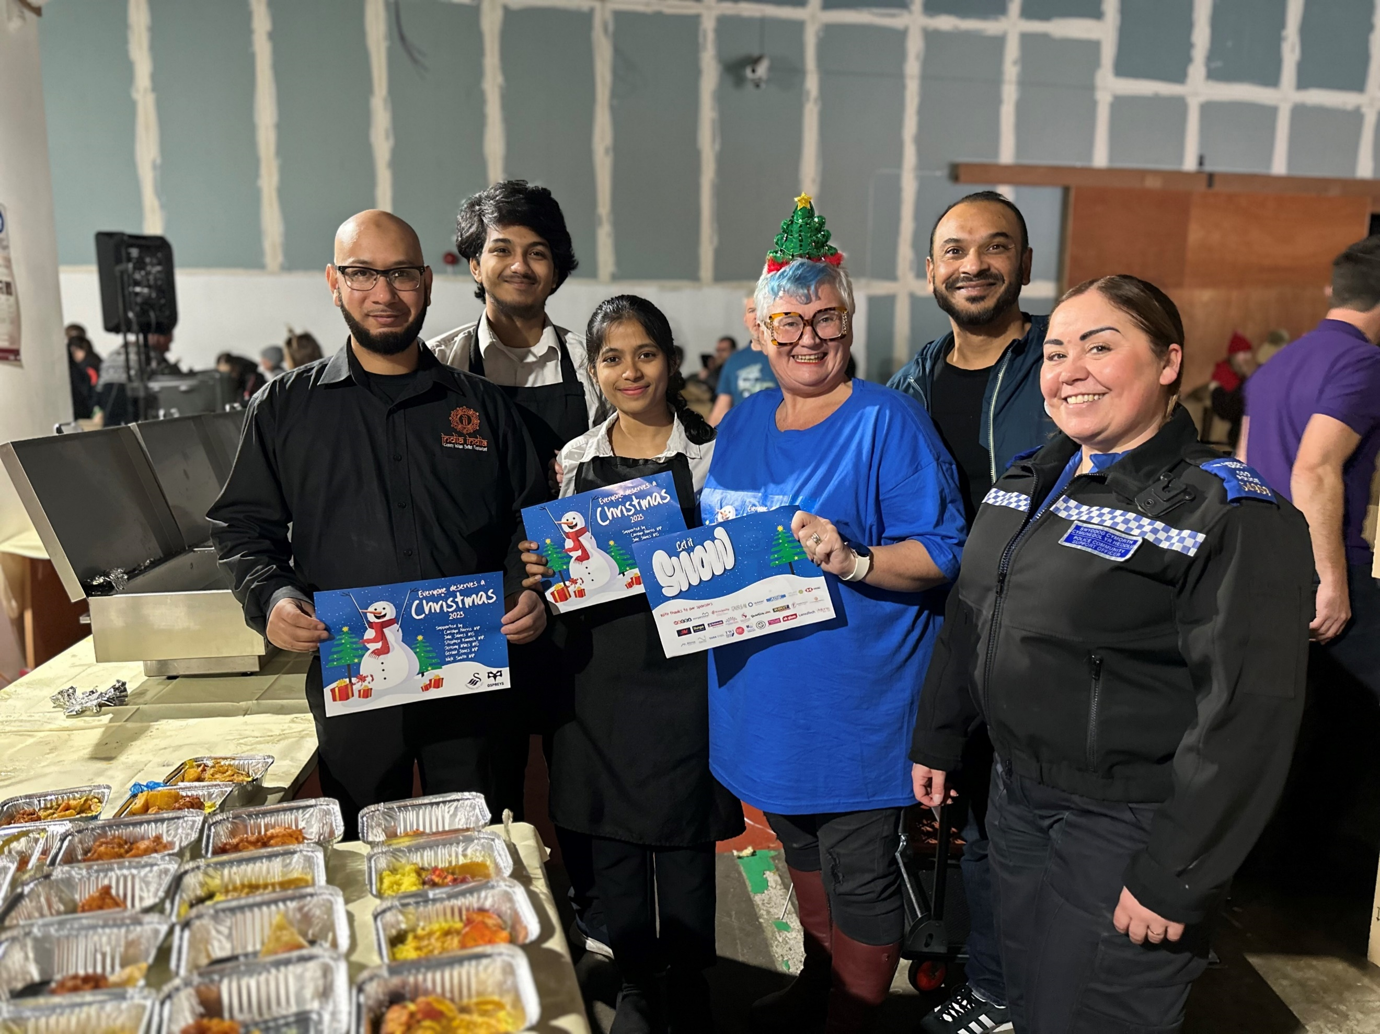
Christmas Eve is not Christmas Eve if the Everyone Deserves team aren’t cooking dinners and delivering to the most vulnerable in our communities. In a final push before the big day, Everyone Deserves provided hot meals and festive treats to those who would be on their own or struggling on Christmas day. Massive thanks to the team at CoedGwilym Pavilion, the ladies from Mecca Bingo, Jason Battye, Huw Cooze, Gavin from Greenspace, and everyone else who gave up on their time to help the community.

Christmas really is the most wonderful time of the year, and I am honoured to be surrounded by so many wonderful people who epitomise that. Thanks to everyone involved, and especially to my own team, who will never know how grateful I am to them for all their help.

Carolyn

